User documentation – help system

# Description

Pet Your Plant is a plant care management app. First, upload a photo and information about your pet plant. Using this profile, create and attach schedules pertaining to anything you wish to do for your plant, whether that be watering, ensuring it is getting enough sunlight, or changing its soil. As the date of your schedule arrives, Pet Your Plant sends you notifications to ensure you don’t forget.

# How to use

Log In

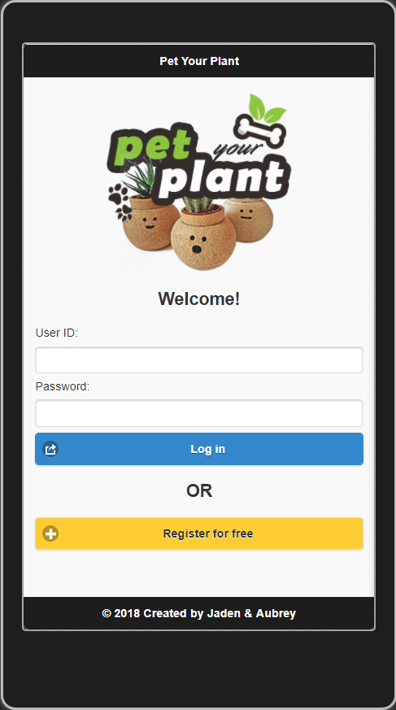

First, log in using an existing account, by entering your credentials and selecting the **Log in** button.   
  
If you do not have an account, select the **Register for free** button.

Register

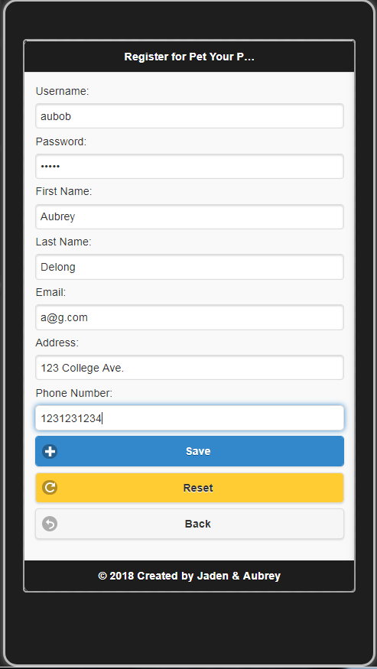

If you must register, complete all the necessary fields and select the **Save** button. If you wish to remove the information you provided, select the **Reset** button. If you no longer wish to register for an account, select the **Back** button.

View The Day’s Briefing and Your Notifications

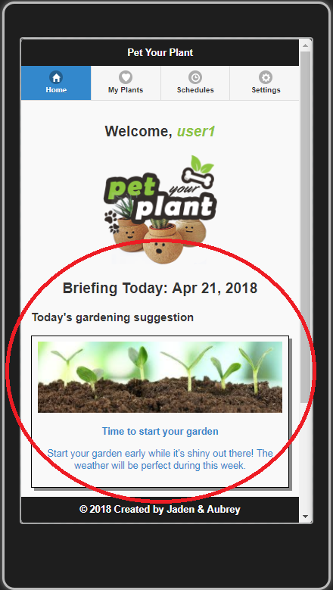

After clicking **Save** from the register page or clicking **Log** **in** from the log in page, you will be sent to your activities summary page.

The summary page contains your daily briefing; an informative link Pet Your Plant provides to give you up to date gardening tips.

Below your daily briefing are all of your plant notifications.

* This is where Pet Your Plant reminds you of any plant care tasks you must perform that day, related to the schedules you create for your plants
* 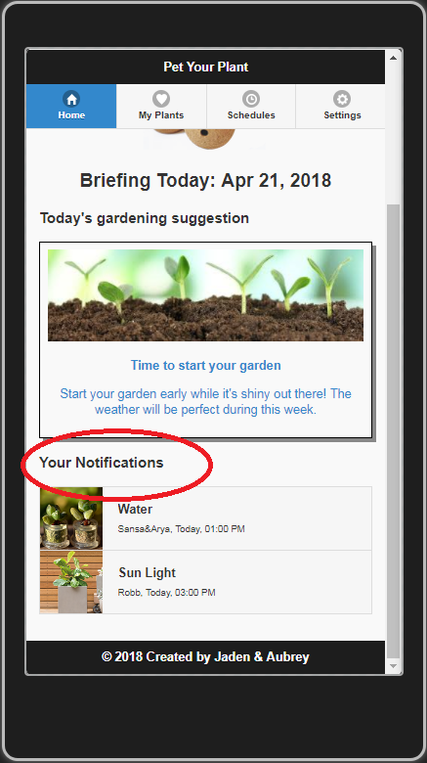By clicking on these links you are redirected to your schedule details page where you can make any schedule adjustments

Manage Your Plants

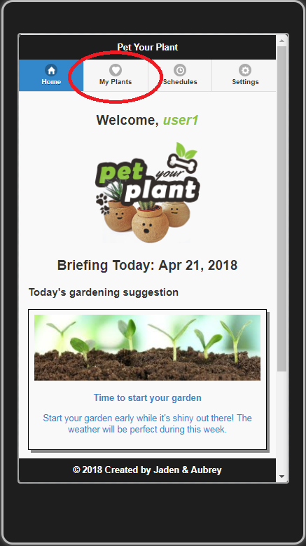

The navigation bar at the top of each page is your door into Pet Your Plant’s every feature. If you select the **My Plants** tab, you will be directed to your plant’s list

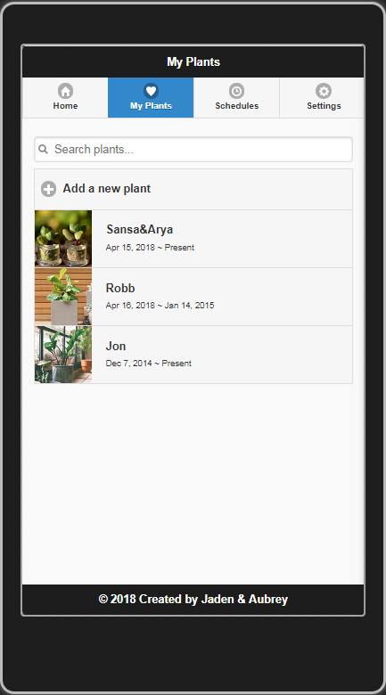

You plant list is where you can find a list of all of your pet plants.

* If you wish to add a new plant, select the **Add a new plant** button.
* If you wish to view the plant’s details, select the plant and you will be redirected to the detail page

Add a New Plant

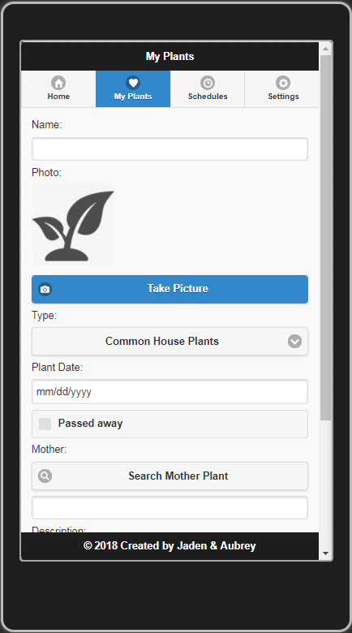

After selecting the **Add a new plant** button from your plant list page, enter:

- The name of your pet

- Take a picture of your pet and upload it to the app

- Select the type from the drop down list

- Select its plant date

- If it has a mother plant, select the **Search Mother Plant** button

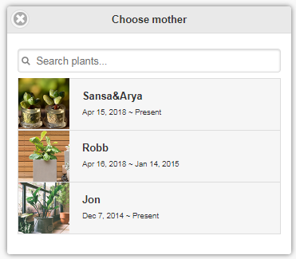

A dialog box with a list of your plants will pop-up. Select a mother from this list.

Add a New Plant (continued)

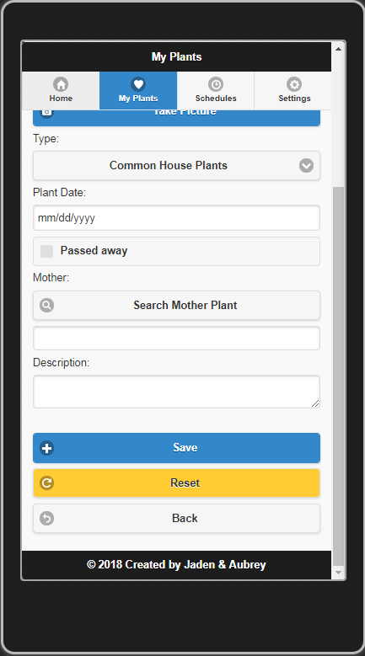

Enter a description of your plant. If you are ready to save your pet plant profile, select the **Save** button.

* You can reset your provided values by selecting the **Reset** button
* You can cancel and go back to your plant list page by selecting the **Back** button

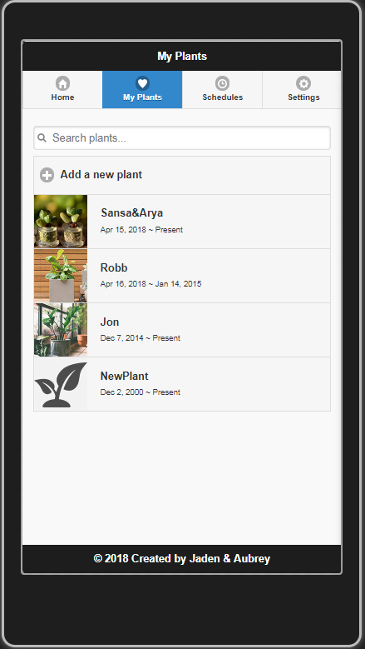

Now you can see your new plant added to your list!

Edit or Delete a Plant

You must select a plant from the plant list page in order to edit or delete it.

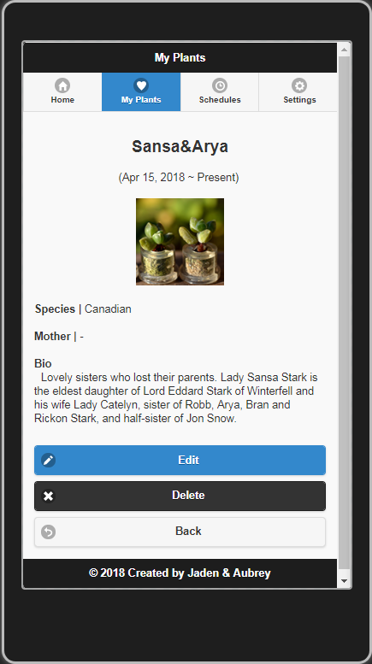

In order to delete the plant, select the **Delete** button.

In order to edit the plant, select the **Edit** button and you will be redirected to the edit plant page. If you wish to cancel, select the **Back** button.

Edit or Delete a Plant (continued)

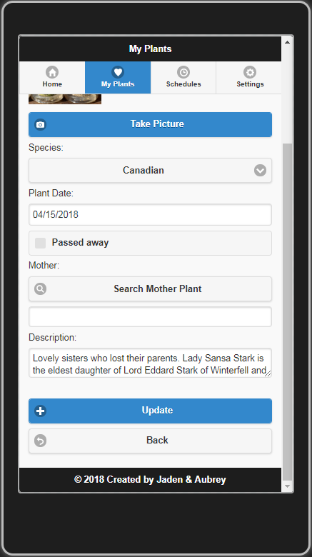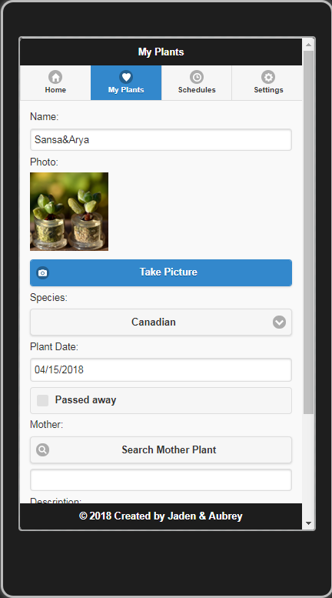

Change your plant profile information and then select the **Update** button.

If you wish to cancel editing your plant, select the **Back** button.

Manage Your Plant Schedules

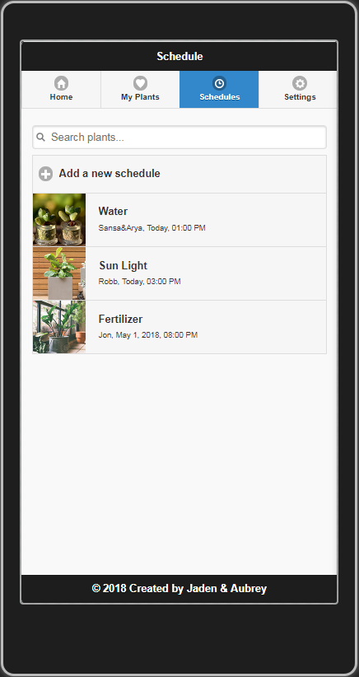

Display a list of all of your schedules by selecting the **Schedules** tab of the navigation bar.



If you wish to add a new schedule to your list, select the **Add a new schedule** button.

Add a New Schedule

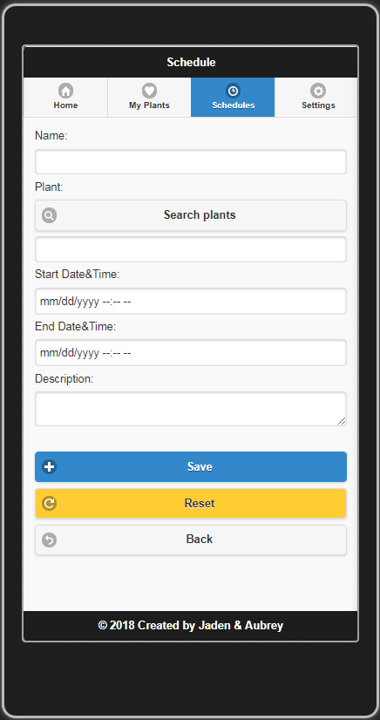

Insert all of the schedule information required, including name, start date and time, end date and time, and a description.

You must tie your schedule to a pre-existing plant. Search for the plant using the **Search plants** button.

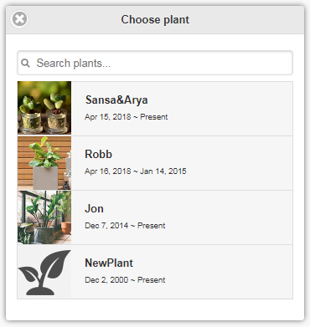

Select a plant from the list to add it to your schedule.

Add a New Schedule (continued)

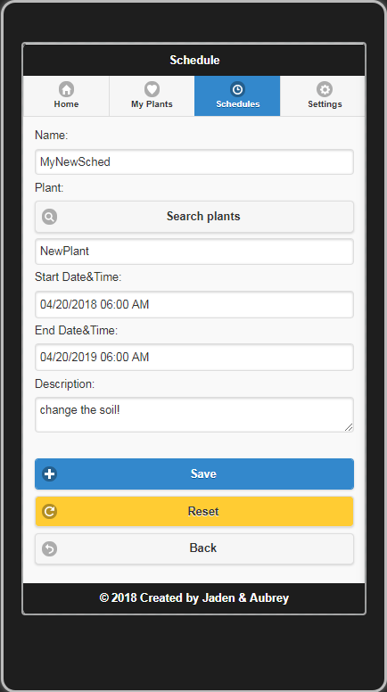

Select the **Save** button to save your new schedule.

* Select the **Reset** button to clear your inputs.
* Select the **Back** button to cancel and return to the list of schedules page.

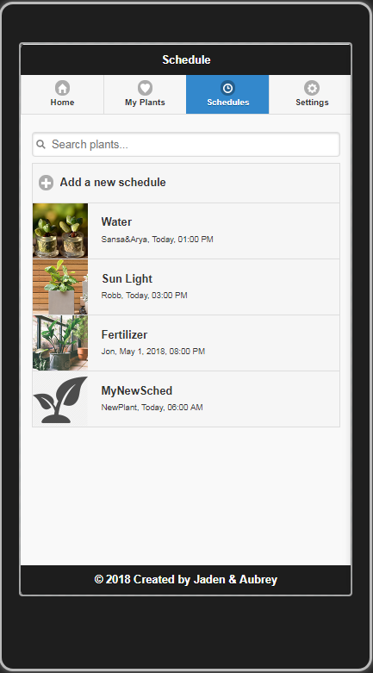

Now you can see your new plant added to your list!

Edit or Delete a Schedule



You must select a schedule from the schedule list page in order to edit or delete it.

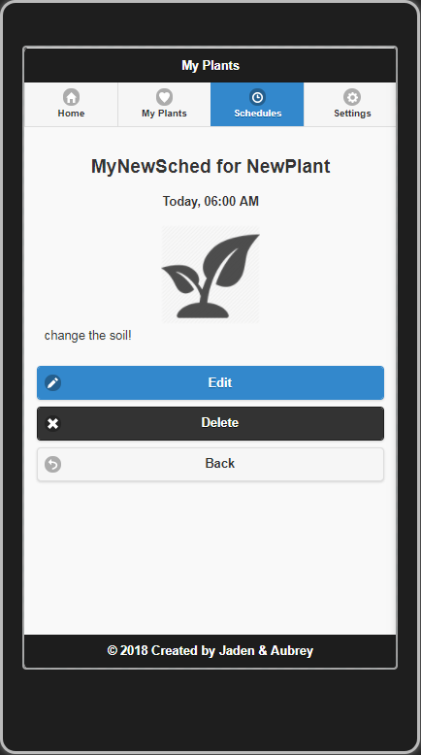

In order to delete the schedule, select the **Delete** button.

In order to edit the schedule, select the **Edit** button and you will be redirected to the edit schedule page. If you wish to cancel, select the **Back** button.

Edit or Delete a Schedule (continued)

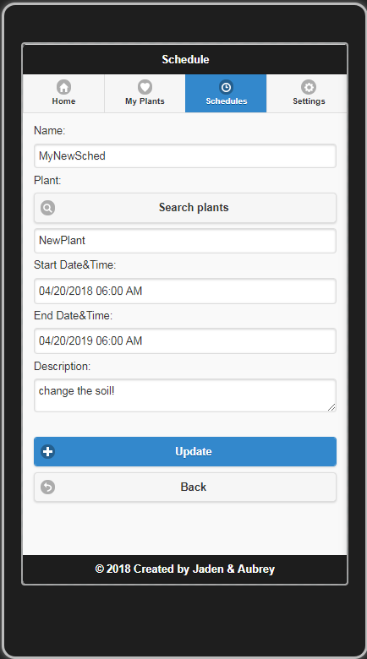

Change your plant schedule information and then select the **Update** button.

If you wish to cancel editing your schedule, select the **Back** button.

View Account Settings

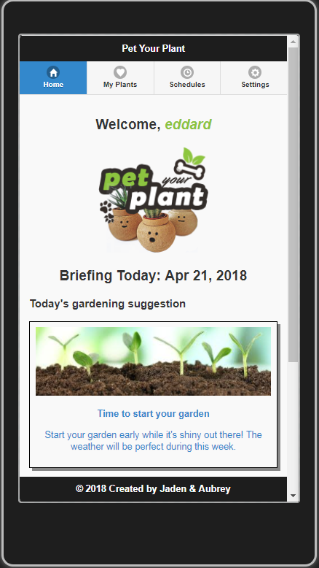

View your account settings or log out by selecting the **Settings** tab from the navigation bar.

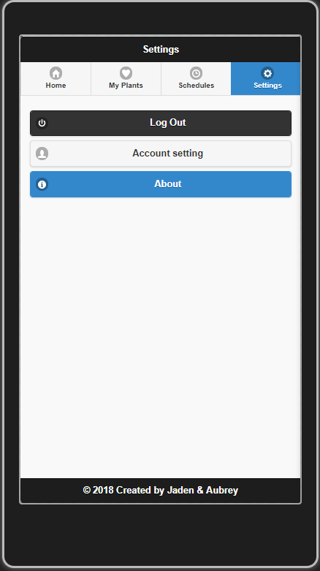

Select the **Account setting** button in order to view or edit your settings. You may also delete your account from this page.

Edit or Delete Account Settings

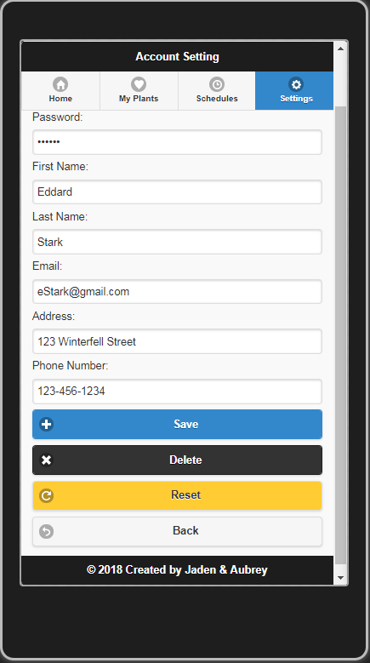

Modify any of your account settings and select the **Save** button to save your new settings.

* If you wish to delete your account, select the **Delete** button.
* If you wish to rest your account settings, select the **Reset** button and all of the input fields will be refreshed.
* If you wish to cancel, select the **Back** button and you will return to the settings page.

Log Out



Select the **Log out** button to exit the Pet Your Plant application and return to the log in page.

View the About Page

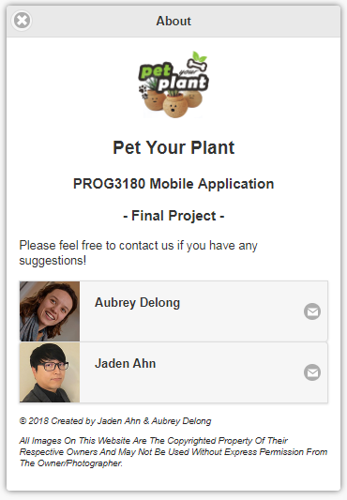

To access information about the developers or to contact us, visit the about page.

The about page can be found under the **Settings** tab and by selecting the **About** button

# About the programmers



Jaden Ahn, Computer Programmer/Analyst

jahn2488@conestogac.on.ca

7672488



Aubrey Delong, Computer Programmer/Analyst

Adelong7545@conestogac.on.ca

7677545